DATA SCIENCE PROJECT

Dataset – IBM HR Analytics Employee
Attrition and Performance

SUBMITTED TO :- MR. SAMARTH AMRUTE

COURCE :- BCA-IBM

SUBMITTED BY :- Naina Kesarwani

ROLL NO :- 24201020053

1.Exploration of Data
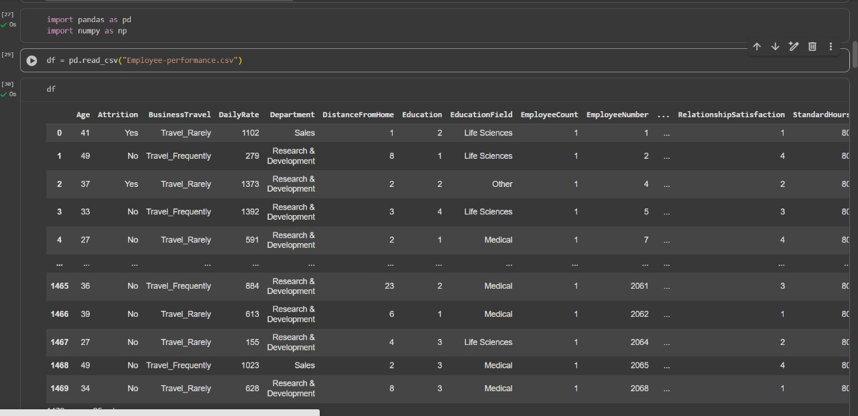
The code shown reads an employee performance CSV file into a pandas DataFrame and displays the first few rows, allowing you to quickly view and analyze various employee attributes like age, attrition status, department, distance from home, education, and job satisfaction, which are useful for understanding workforce trends and patterns.
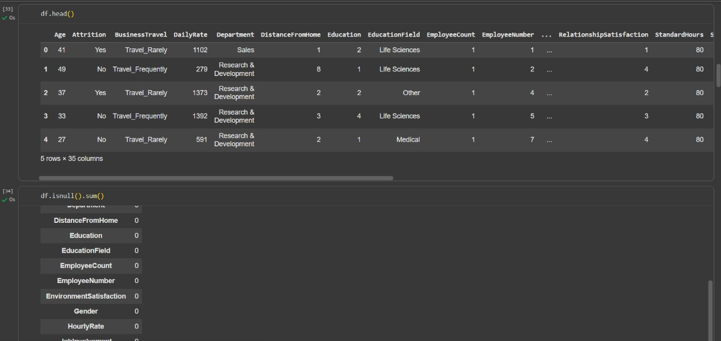
The functions shown in your screenshot are df.head() and df.isnull().sum(). The df.head() function displays the first few rows (default is 5) of your DataFrame, giving a quick view of your data and helping you understand the column names and typical values in each feature. The df.isnull().sum() function counts the number of missing (null) values in each column, which is crucial for identifying and handling incomplete data before doing any analysis or modelling.
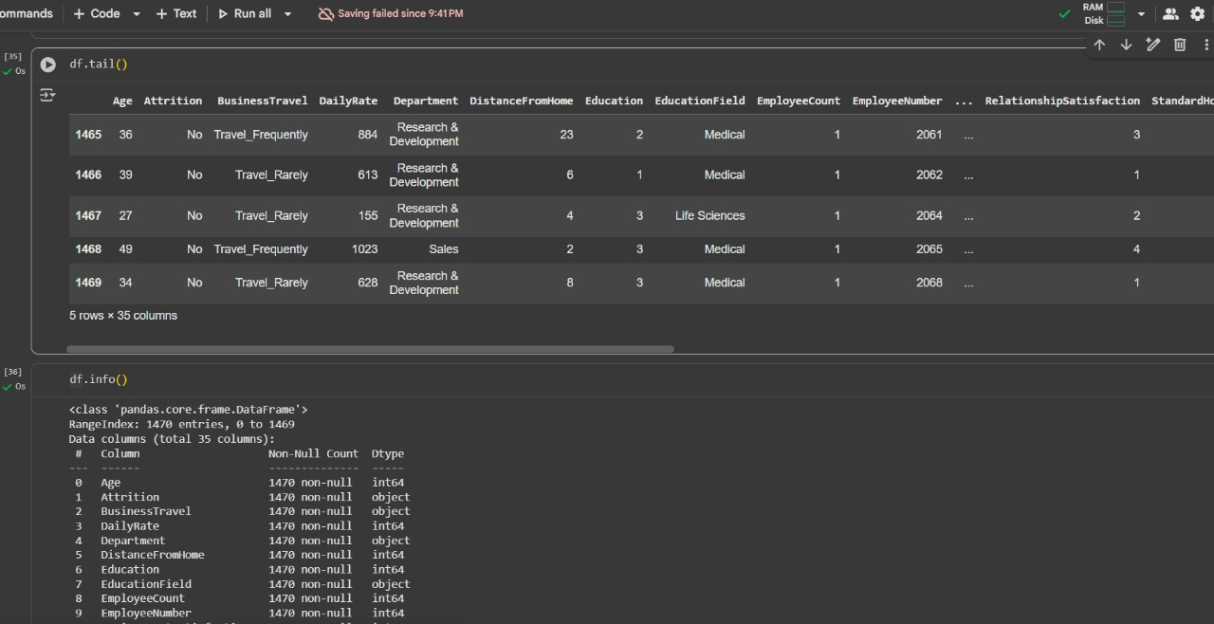
df.tail() : This function displays the last 5 rows of a DataFrame by default.
It helps you quickly see the ending records of your dataset.
df.shape : Returns a tuple showing the dataset’s dimensions — (rows, columns).
Useful to check dataset size instantly.
2.Fixing and Cleaning the Data
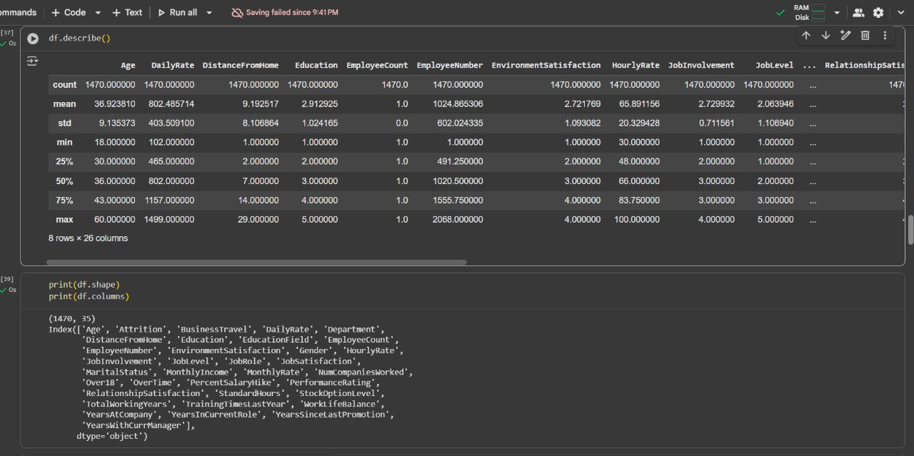
df.describe() : Gives statistical summary of numeric columns like count, mean, min, max, and quartiles.
It helps understand data distribution and detect outliers quickly.
df.shape : Returns a tuple showing the dataset’s dimensions — (rows, columns).
Useful to check dataset size instantly.
df.columns : Displays a list of all column names in the DataFrame.
Helps identify or access specific columns easily.
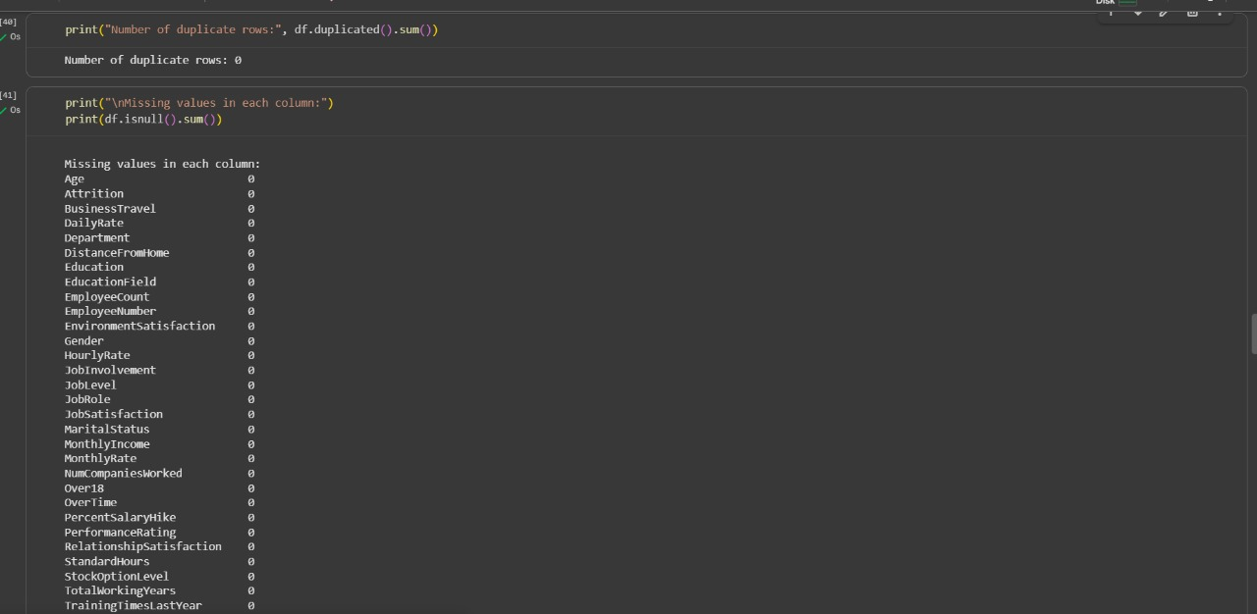
The code first prints out the total number of duplicate rows in the dataset, helping to identify any data redundancy. Next, it checks for missing values in each column, allowing you to quickly spot any gaps in your data that might need to be handled before analysis.
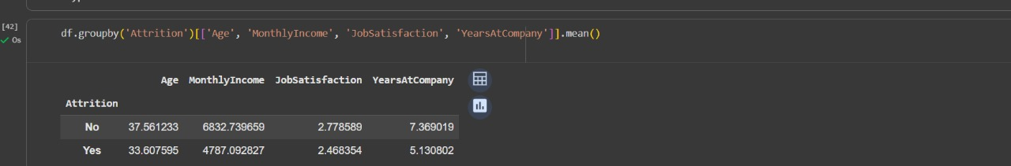
groupby() : The groupby() function in pandas is used to split data into groups based on one or more columns.
It allows you to perform aggregate functions (like mean, sum, count) on each group separately.
3.Insights
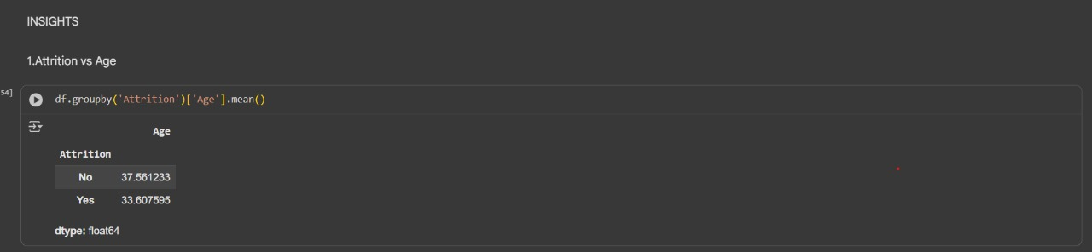
This code groups the data by ‘Attrition’ and calculates the average age for each group.
It shows the age difference between employees who stayed and those who left.
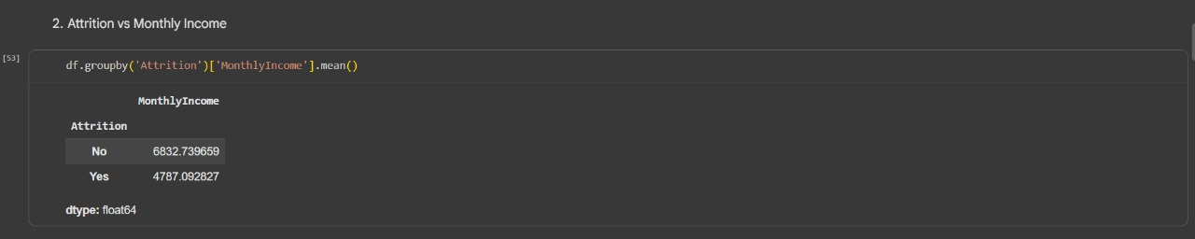
Mean ()This code groups the data by ‘Attrition’ and calculates the average monthly income for each group.
It shows that employees who left the company generally had a lower income than those who stayed.
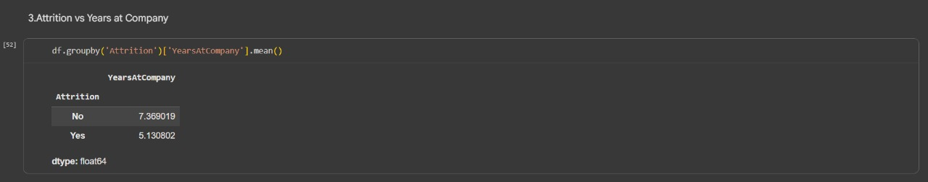
code groups the data by ‘Attrition’ and calculates the average years spent at the company for each group.
It shows that employees who left the company (Yes) had worked for fewer years compared to those who stayed (No).
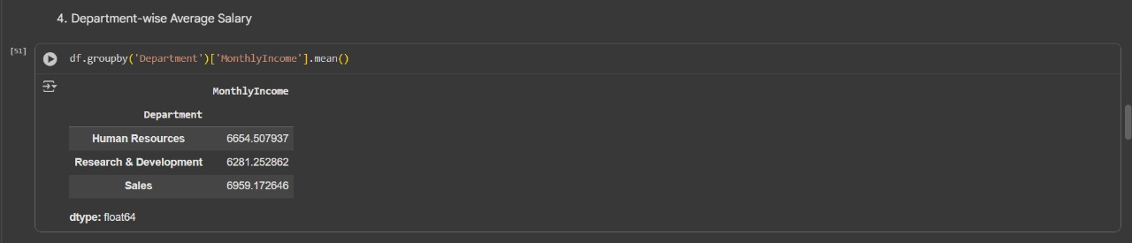
It groups the data by Department, sorts by a summary metric, and then computes the average salary (MonthlyIncome) per department, producing a compact summary panel. The second line displays a bar or small table of MonthlyIncome across departments to compare human resources, research & development, and sales, indicating which department has higher or lower average pay.
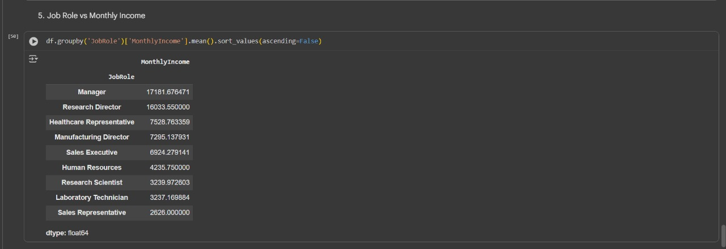
This code groups the data by job role, calculates the mean monthly income for each role, and then sorts them in descending order to show which job roles have the highest average salaries. It helps compare earnings across different positions and identify which roles are best paid in your dataset.
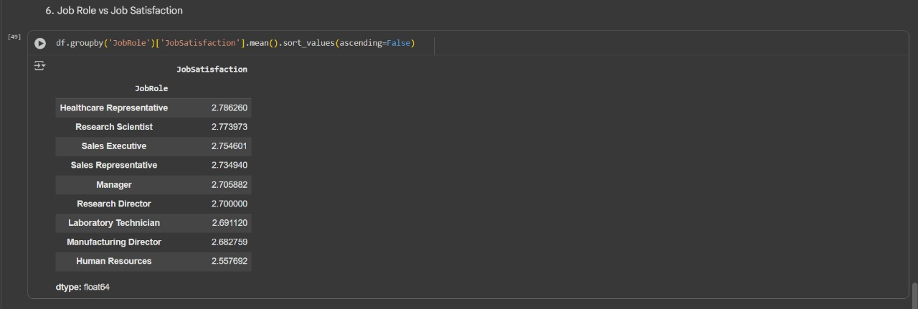
Alternatively, this code demonstrates how to use Pandas groupby and mean operations to compare job satisfaction averages across different job roles, making it easy to see which roles have the most or least satisfied employees in your dataset.
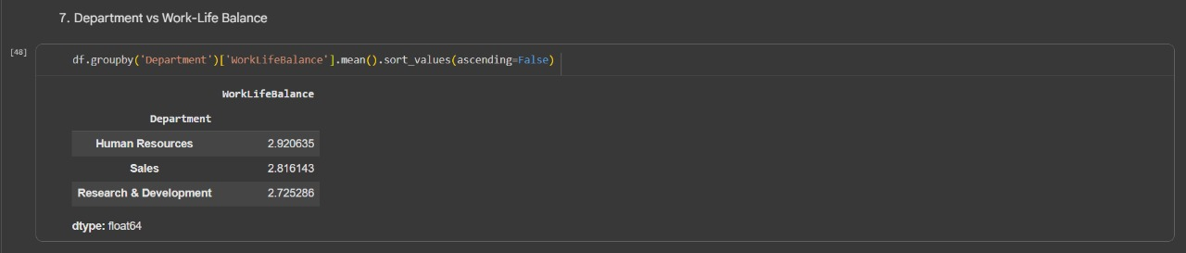 This code groups the data by department and calculates the average work-life balance score for each department, then sorts them in descending order. It lets you easily compare which department has the best or worst perceived work-life balance among employees.
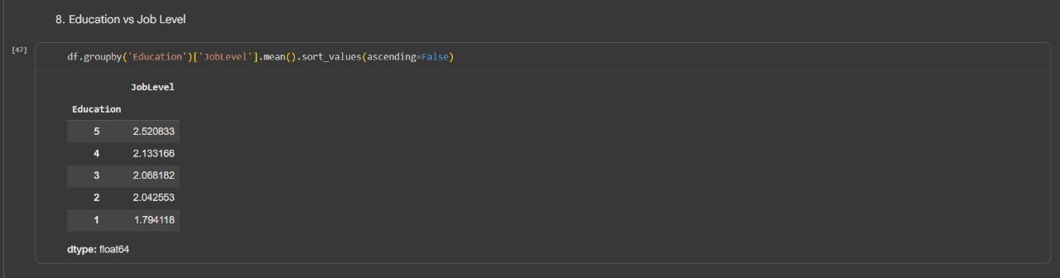
This operation examines how different levels of education correlate with average job roles in the organization by grouping the data according to education level, then calculating and ranking the mean job level for each group, highlighting whether advanced education leads to higher or lower positions within the company.
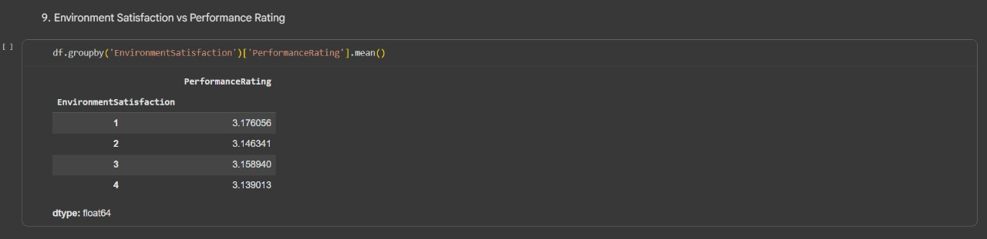
This snippet groups employees by their level of environment satisfaction and calculates the mean performance rating within each group. It enables you to observe if those more content with their work environment tend to receive higher performance scores.
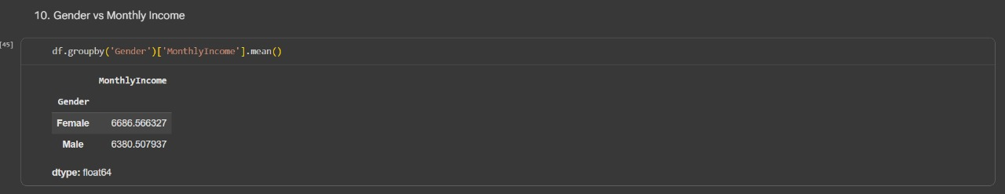
This code separates the dataset based on gender and computes the average monthly earnings for each group. By doing so, it allows a straightforward comparison of the typical monthly income of male and female employees in your data.
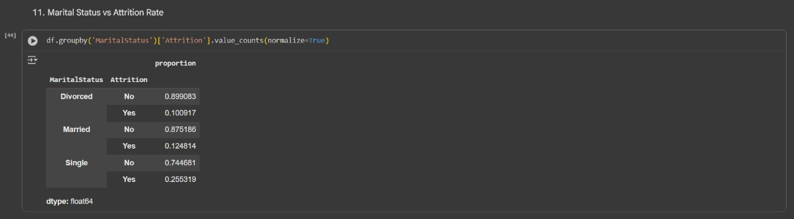
This code categorizes employees by marital status and calculates the proportion of those with and without attrition for each group. It helps reveal whether being single, married, or divorced impacts the likelihood of leaving the company.
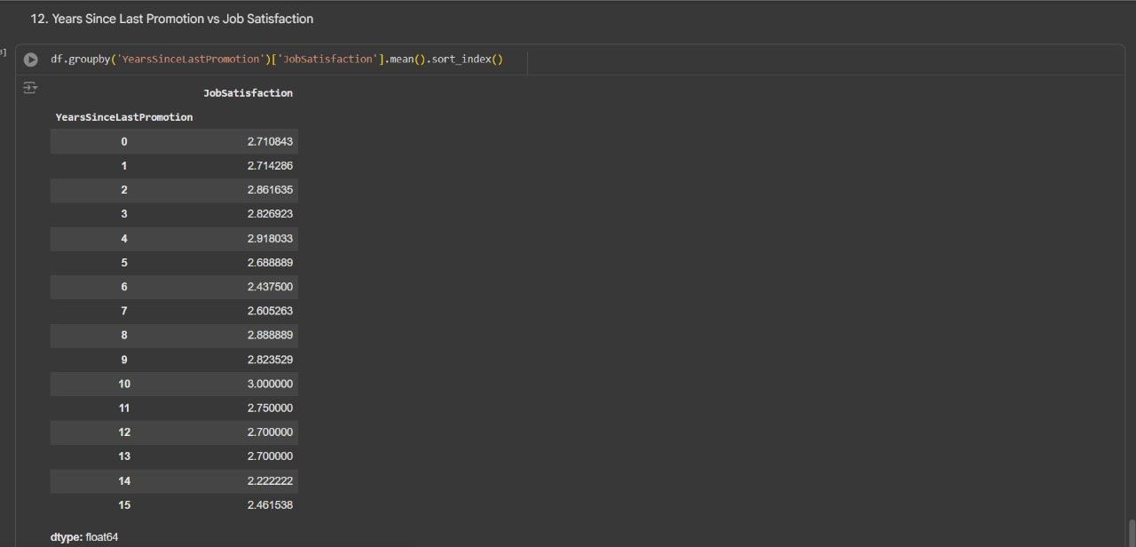
This code organizes employees by the number of years since their last promotion and calculates the average job satisfaction for each group. It helps identify if not being promoted for a longer time affects how satisfied employees feel at work.
REFRENCES & SOURCES :-

[1] DATA SOURCES :- KAGGLE
[2] LECTURE NOTES PROVIDED BY MR.SAMARTH AMRUTE(SIR)
[3] SEARCH ENIGINE :- FOR EXPLANTION THE CODE
[4] DEBUGGING ERROR :- GEMINI
THANKYOU AND HAVE A NICE DAY AHEAD!!

